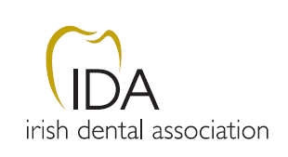

IRISH DENTAL ASSOCIATION LIMITED

A N N U A L G E N E R A L M E E T I N G 2016

Thursday 21st April 2016 at 7:00 pm (est)
in the Radisson Hotel, Galway.

A G E N D A

Agenda Item 1: Call to Order and Apologies

Agenda Item 2: Adoption of Minutes of 2015 AGM & Standing Orders

Agenda Item 3: Report of Chief Executive Officer

Agenda Item 4: Officers’ Reports
4.1 Honorary Secretary’s Report
4.2 Honorary Treasurer’s Report

Agenda Item 5: Consideration of Motions

Agenda Item 6: Presentation – IDA Roll of Honour

Agenda Item 7: President’s Valedictory Address

Agenda Item 8: Inauguration of President 2016-2017

Agenda Item 9 : Address re IDA Conference 2017

Agenda Item 10: Adjournment

